EXPERIMENT-08 DHILIPAN M
21/07/2026 192411038

DEPTH FIRST SEARCH (DFS) ALGORITHM
AIM:
To write a Python program to implement the Depth First Search (DFS) algorithm for traversing a graph and finding a path between two nodes.
ALGORITHM:
Step 1: Represent the graph using an adjacency list.
Step 2: Read the start node and goal node.
Step 3: Initialize an empty stack and mark the start node as visited.
Step 4: Pop the top node from the stack and check whether it is the goal node.
Step 5: Push all unvisited neighboring nodes onto the stack.
Step 6: Repeat the process until the goal node is found or the stack becomes empty.
PROGRAM:
graph = {
'A': ['B', 'C'],
'B': ['D', 'E'],
'C': ['F', 'G'],
'D': [],
'E': [],
'F': [],
'G': []
}

start = 'A'
goal = 'G'

stack = [(start, [start])]
visited = set()

while stack:
node, path = stack.pop()

if node == goal:
print("Goal Found")
print("Path:", " -> ".join(path))
break
if node in visited:
continue
visited.add(node)
for neighbor in reversed(graph[node]):
if neighbor not in visited:
stack.append((neighbor, path + [neighbor]))
else:
print("Goal Not Found")

OUTPUT:

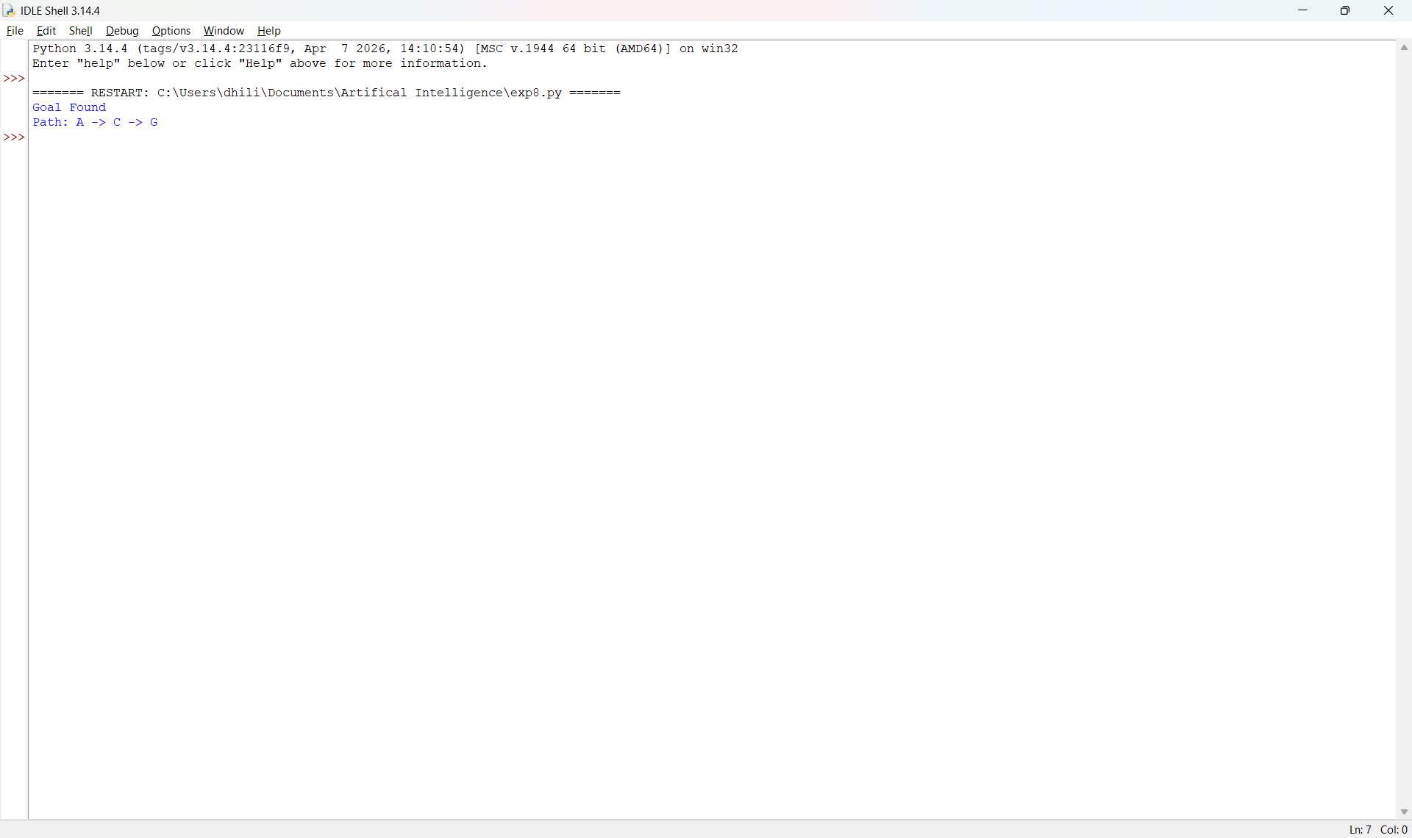

RESULT:
Thus, the Python program to implement the Depth First Search (DFS) algorithm was implemented successfully and the required output was obtained.

